**TASK 1:** While utilizing the Linux commands studied so far, provide an example *(other than the one shown in this Lab)* of a combination of several Linux commands in which pipes are used more than once. Also provide a snapshot of the generated output.

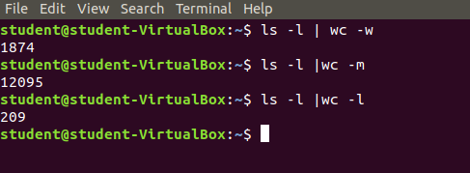

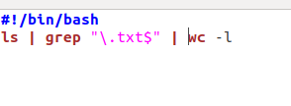

**TASK 2:** Write C program to print all alphabets from a to z using while loop.(using ASCII)

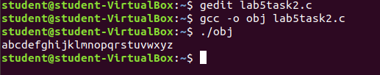

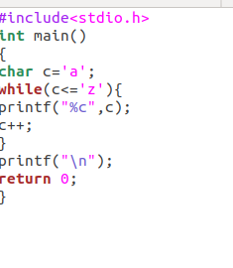

**TASK 3:** **Write a shell script that records the full path of all the files present within a directory into a record.txt file. Along with full path name, the script should also record the number of words, characters and lines within each file**

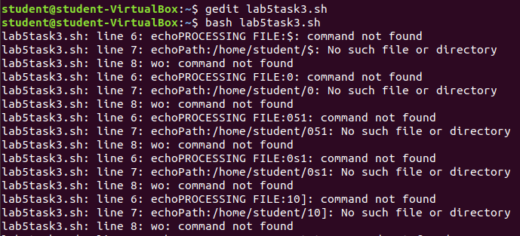

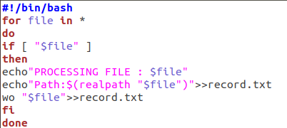

**TASK 4:** Write a C program that asks the user to provide an integer input in the ***main()*** function. The program would call a function ***even_odd()*** from the ***main()*** function, where the function ***even_odd()*** accepts an integer as an argument, determine and display if the passed integer is either even or odd.

